**How to run the QAOA**

1. **How to run the MCLP with quantumR:**

* Create a Python 3.7 conda environment: In the Anaconda Powershell execute the following:
  + conda create -n **myquantum** python=3.7
  + conda activate **myquantum**
* without closing, go to the folder of the project, and executes the command:
  + pip install -r requirements.txt
* Install the ipykernell to allow jupyter notebook see the environment:
  + conda install -c anaconda ipykernel
  + python -m ipykernel install --user --name=**myquantum**

1. **Get the license for Gurobipy**

* Go to the Gurobi website: <https://www.gurobi.com/>
* Signup as an User, an then log in. Then click on “Request a Free Academic License”, “Academic Named-User License”
* Download the Academic Gurobi and get a license:

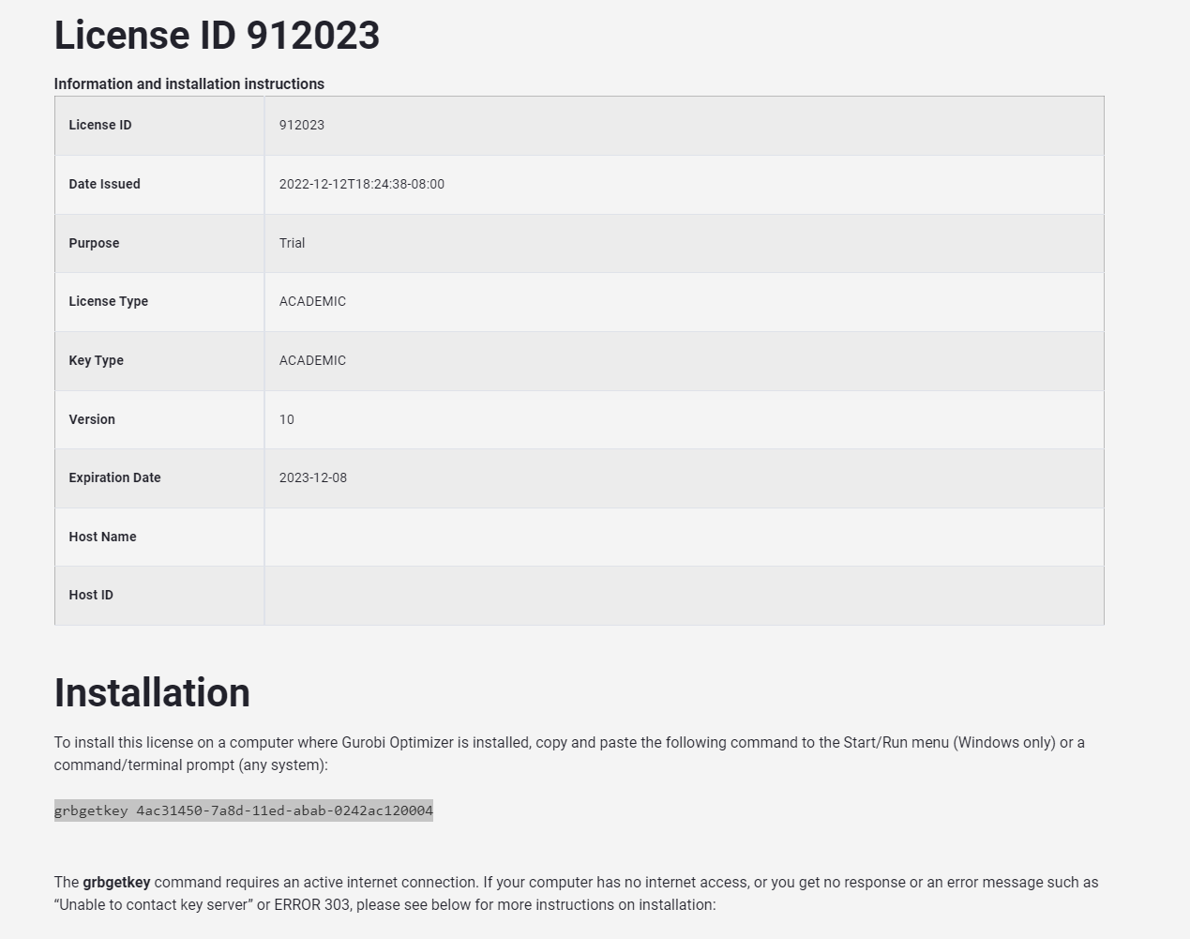

* Execute the following command in CMD console (must be connected to the University’s network)
  + grbgetkey ###
* Save the license file in a known location.
* Copy the license file
* And paste it in the location of the Gurobipy Python library. [Inside the folder of the anaconda environment, for example: C:\Users\osvga\anaconda3\envs\myquantum\Lib\site-packages\gurobipy\]

If the gurobi is well configured, when executing the following cell it will show the academic license:

1. Open the jupyter notebook, open **QAOA_Optimization**, change the kernel to **myquantum,** and run the file, it will display some elements, and will save the files into a folder in the working path.